Explaining the code in sections

## Section 1

In section 1 this is where the 2 libraries are imported that are used in the program are imported. The csv library allows python to read and write data in a csv format and the requests library allows python to go onto a website and grab data from the internet. I have also defined in this area the URL of where the .csv file will be downloaded

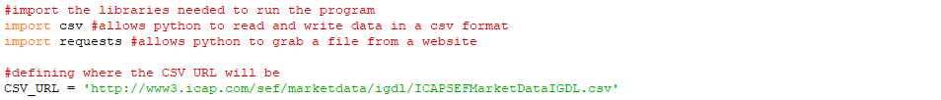

## Section 2

Within this section is where the CSV file downloaded from the internet is analysed and read by python. It is then put into a list called ‘csv_list’ where each line has its own row. The total is also calculated by adding up each value in row[25] which is also known as column Z on a spreadsheet.

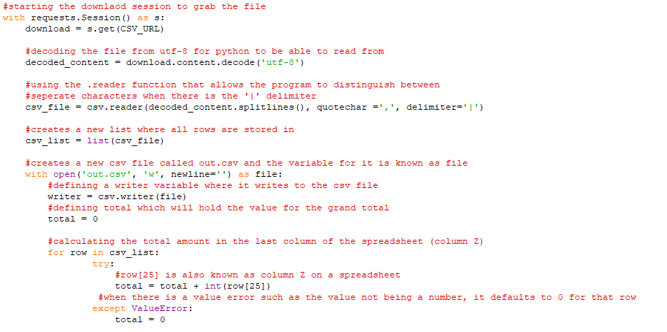

Outputs:

The only output from this section is the creation of the spreadsheet:



## Section 3:

Within this section, the csv file is read and analysed by python and put into rows and columns through the delimiter of ‘|’. The total is also calculated from column Z and added to a new list called ‘resultsrow’ that will be added to the list ‘csv_list’ which will form a new row to be added. All of the contents in the list csv_list is written to the spreadsheet. The results are also outputted via python.

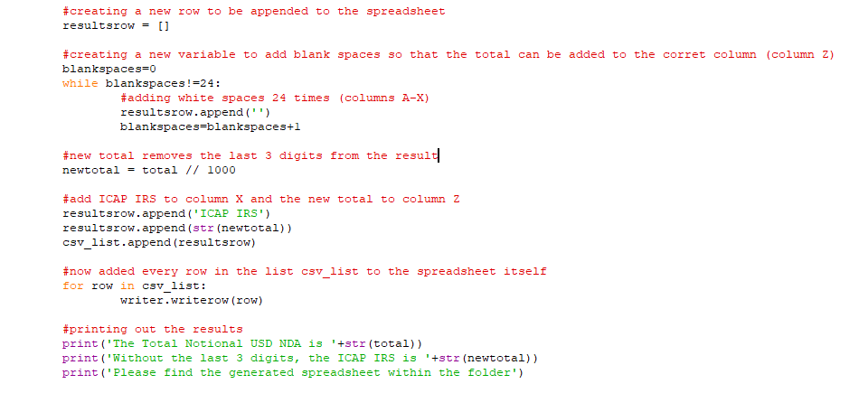

Output:

